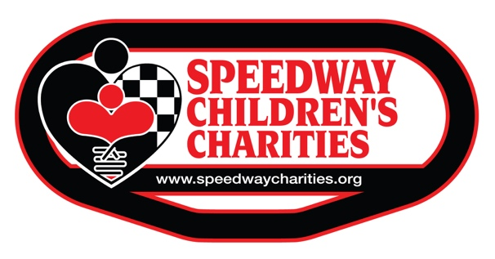

NON-CASH CONTRIBUTION FORM

Please complete the following information so that we may properly recognize your donation

Donor Name:
Address:
Telephone:
Email Address:

Date of Contribution: MM/DD/YYYY
Description of Merchandise or Service:

Fair Market Value: $ 0.00
Method used to determine Fair Market Value (Examples: Appraisal, Catalog, Replacement cost new,
Thrift shop value, etc.):
Please list any restrictions, conditions or special instructions concerning this gift:

Signature:
Date: MM/DD/YYYY

Please accept our most sincere thanks on behalf of Speedway Children’s Charities
and the many children’s organizations that benefit from our grant program each year!

